**Geography April 12th:**

**Starter:**

Tectonics: the process that controls the structure and properties of the Earth's crust and its evolution through time.

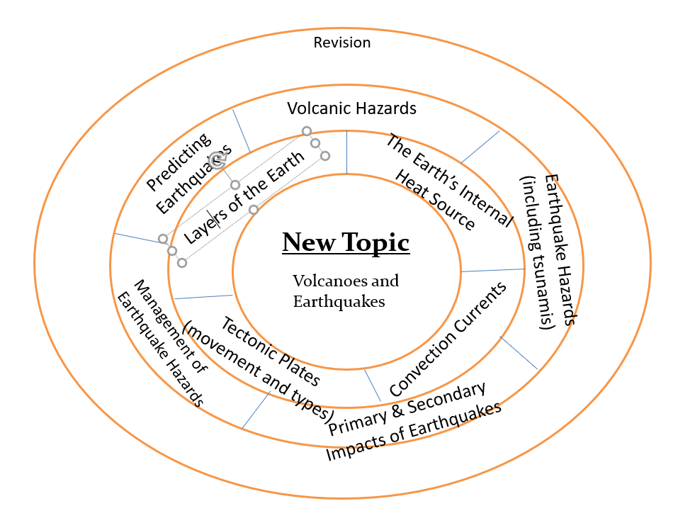

**Task 1:**

1. **Earth Structure:** It can be divided into the crust, upper mantle, lower mantle, outer core, and inner core
2. **Inner Core:** The innermost part of the Earth, believed to be made of a nickel-iron alloy.
3. **Outer Core:** The part of the Earth between the mantle and inner core, responsible for generating the planet's magnetic field.
4. **Mantle:** The mantle is a layer within the Earth between the crust and the core. Magma comes from the mantle.
5. **Crust:** The outer-most layer of the Earth
6. **Tectonic Plate:** the process that controls the structure and properties of the Earth's crust and its evolution through time.
7. **Magma:** Lava from underground
8. **Subduction:** The sideways and downward movement of the edge of a plate of the earth's crust into the mantle beneath another plate.
9. **Pyroclastic Flow:** A dense, destructive mass of very hot ash, lava fragments, and gases ejected explosively from a volcano and typically flowing at great speed.
10. **Natural Disaster:** A destructive event naturally caused
11. **Infrastructure:** The basic physical and organizational structures and facilities
12. **Focus:** A place where an earthquake begins.
13. **Epicentre:** the point on the earth's surface vertically above the focus
14. **Seismic wave:** an elastic wave in the earth produced by an earthquake or other means.
15. **Tsunami:** a long, high sea wave caused by an earthquake or other disturbance.